**Module: R3: DLD + DSD**

**Section:** Combination Circuits **Task:** Assignment 1

**Assignment 1**

**Combination Circuits**

1. **1’s and 2’s Complement:**
   * **Solution:**

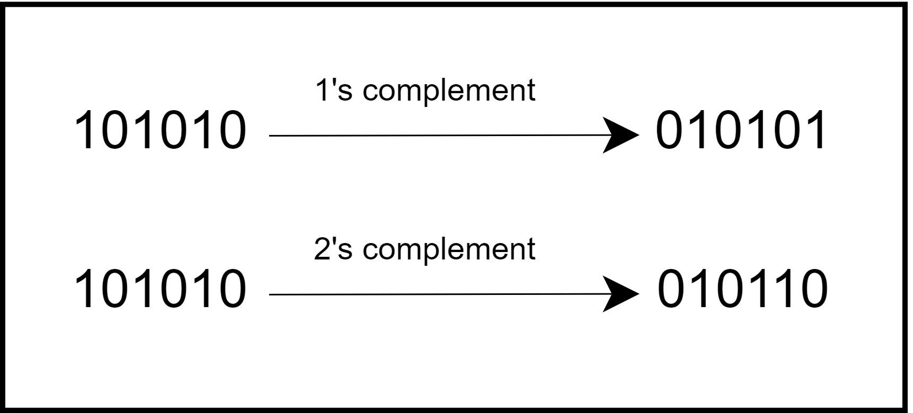

1. **3-to-8 Line Decoder using 2-to-4 Decoders:**
   * **Solution:**

| **Table for 3x8** | | | |
| --- | --- | --- | --- |
| A | B | C | F |
| 0 | 0 | 0 | m0 |
| 0 | 0 | 1 | m1 |
| 0 | 1 | 0 | m2 |
| 0 | 1 | 1 | m3 |
| 1 | 0 | 0 | m4 |
| 1 | 0 | 1 | m5 |
| 1 | 1 | 0 | m6 |
| 1 | 1 | 1 | m7 |

The block-level implementation will look following:

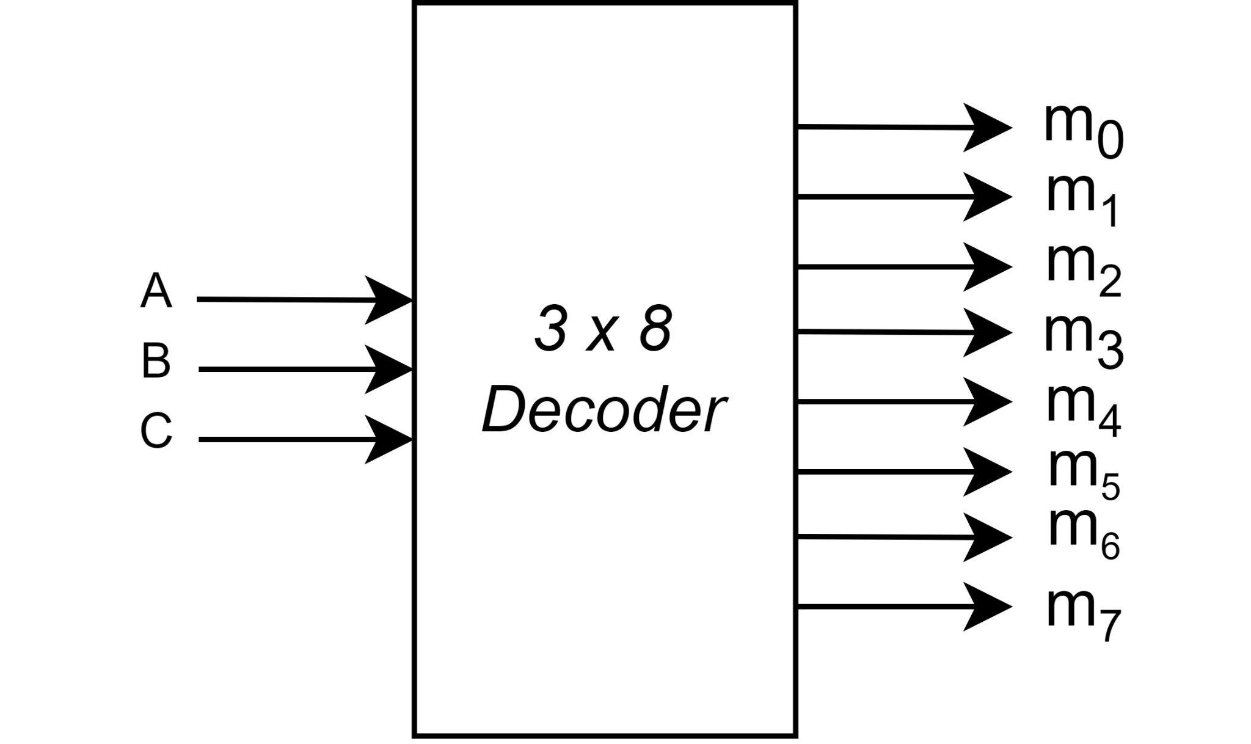

This decoder can be further broken down to two ***2 x 4*** decoders. The input A can

be used to enable either of the two ***2 x 4*** decoders. The implementation is given below:

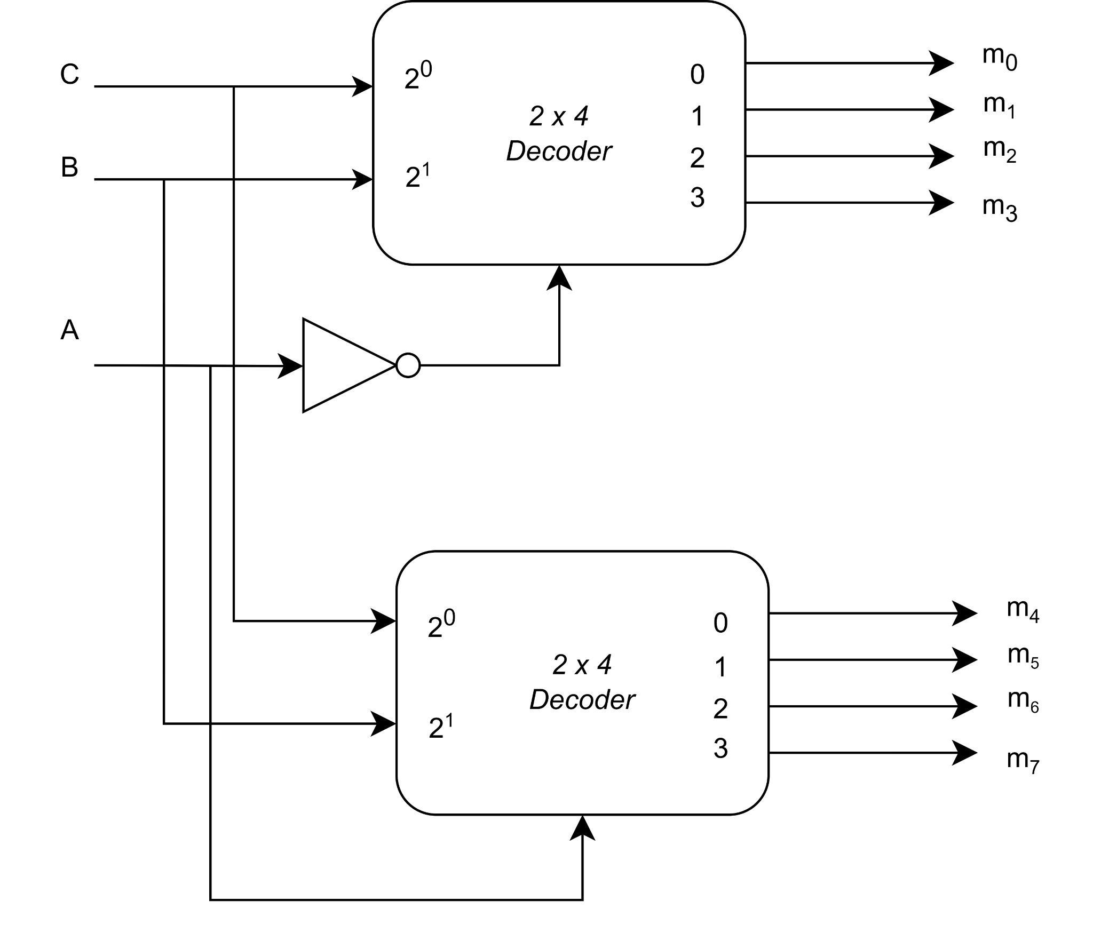

1. **Implement a full-adder with two 4 x 1 multiplexers:**
   * **Solution:**

A full adder can be implemented using two 4 x 1 multiplexers, one for each of sum and carry. A block level implementation of the full adder is as follows:

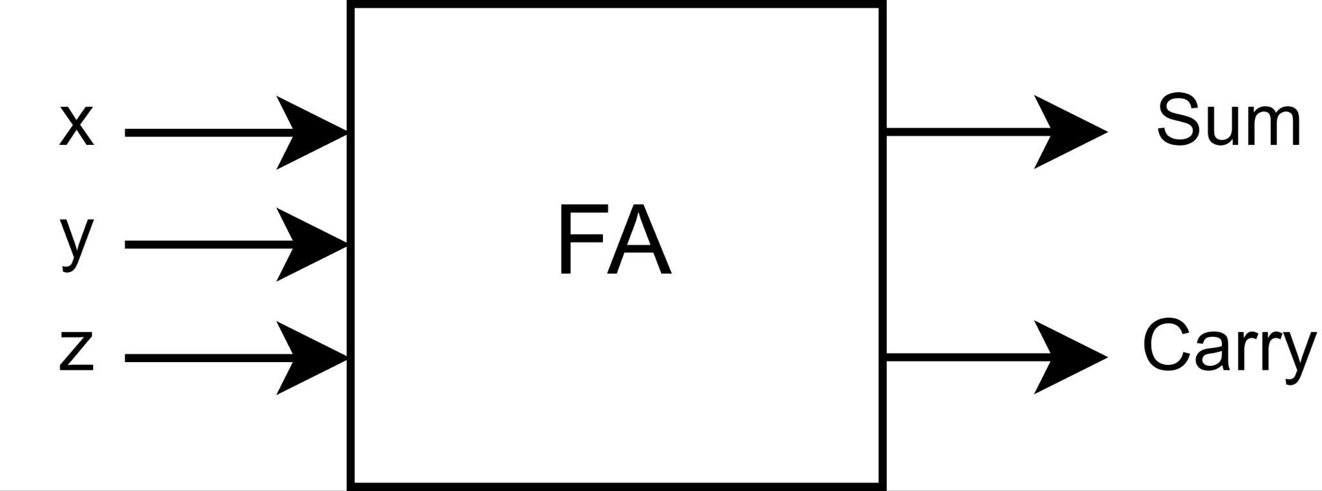

The block can be further broken into two 4 x 1 multiplexers. Using truth tables:

| Truth table for Sum | | | | |
| --- | --- | --- | --- | --- |
| Select Lines | |  | | |
| x | y | z | Sum | F |
| 0 | 0 | 0 | 0 | F = z |
| 0 | 0 | 1 | 1 |
| 0 | 1 | 0 | 1 | F = z' |
| 0 | 1 | 1 | 0 |
| 1 | 0 | 0 | 1 | F = z' |
| 1 | 0 | 1 | 0 |
| 1 | 1 | 0 | 0 | F = z |
| 1 | 1 | 1 | 1 |

| Truth table for Carry | | | | |
| --- | --- | --- | --- | --- |
| Select Lines | |  | | |
| x | y | z | Carry | F |
| 0 | 0 | 0 | 0 | F = 0 |
| 0 | 0 | 1 | 0 |
| 0 | 1 | 0 | 0 | F = z |
| 0 | 1 | 1 | 1 |
| 1 | 0 | 0 | 0 | F = z |
| 1 | 0 | 1 | 1 |
| 1 | 1 | 0 | 1 | F = 1 |
| 1 | 1 | 1 | 1 |

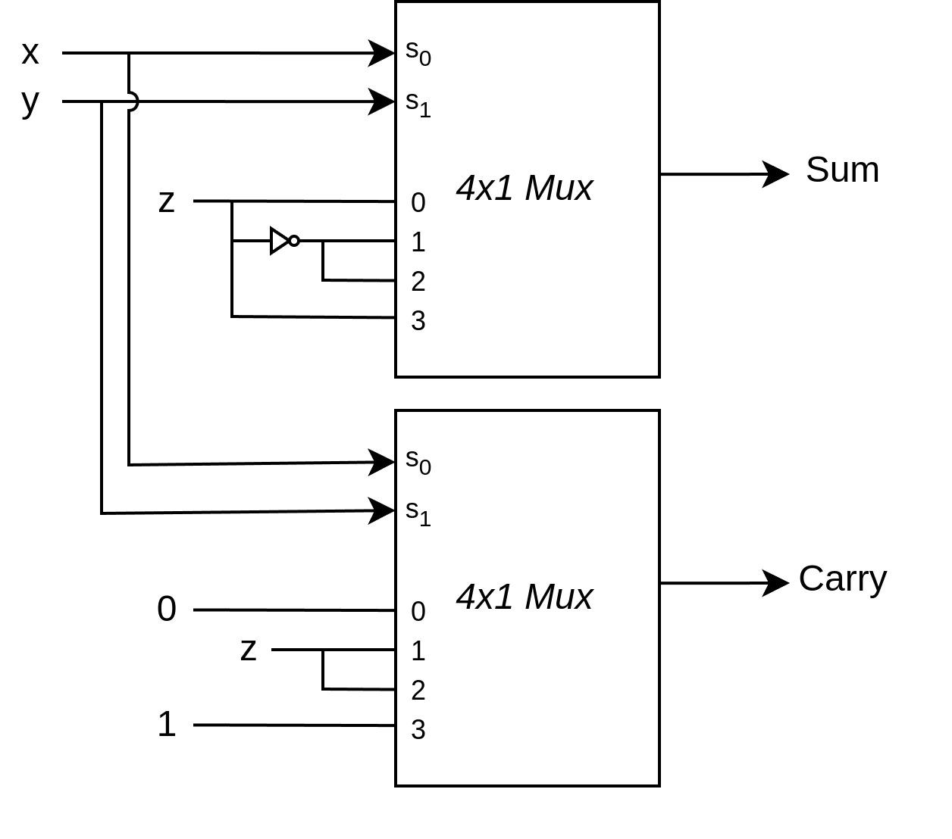

1. **Implement F=Σm(1,2,3,6,7) using 4 x 1 mux:**
   * **Solution:**

| **Truth table** | | | | |
| --- | --- | --- | --- | --- |
| **Select Lines** | |  | | |
| **A** | **B** | **C** | **F=Σm(1,2,3,6,7)** | **F** |
| 0 | 0 | 0 | 0 | F = C |
| 0 | 0 | 1 | 1 |
| 0 | 1 | 0 | 1 | F = 1 |
| 0 | 1 | 1 | 1 |
| 1 | 0 | 0 | 0 | F = 0 |
| 1 | 0 | 1 | 0 |
| 1 | 1 | 0 | 1 | F = 1 |
| 1 | 1 | 1 | 1 |

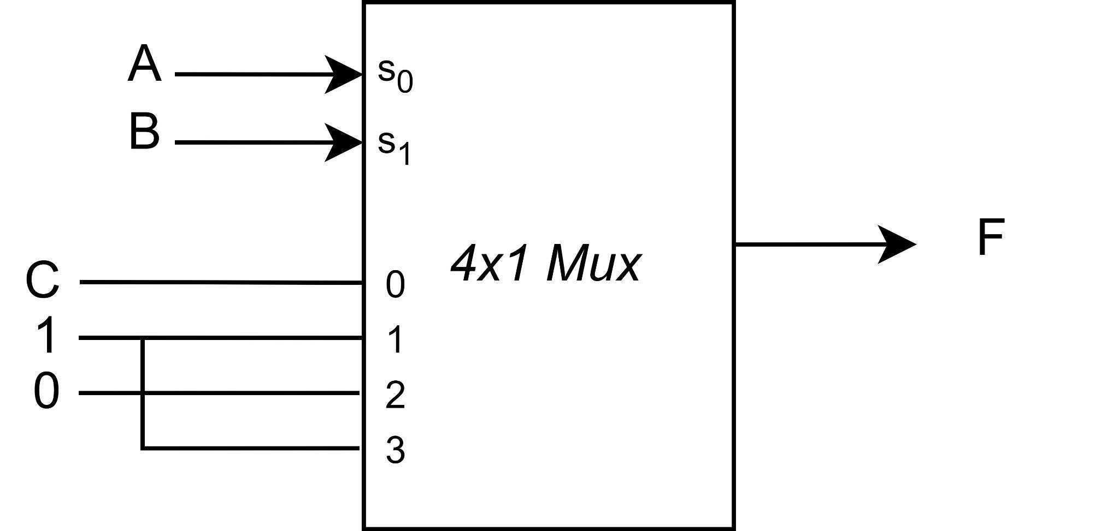

1. **NOR circuit realization of the function f = (b +c +d)(a’ + b + c)(a’ + d):**
   * **Solution:**

Simplifying the function gives us the following equation for NOR equivalent circuit.

f = [(b+c+d)’ + (a’+b+c)’ + (a’+d)’]’

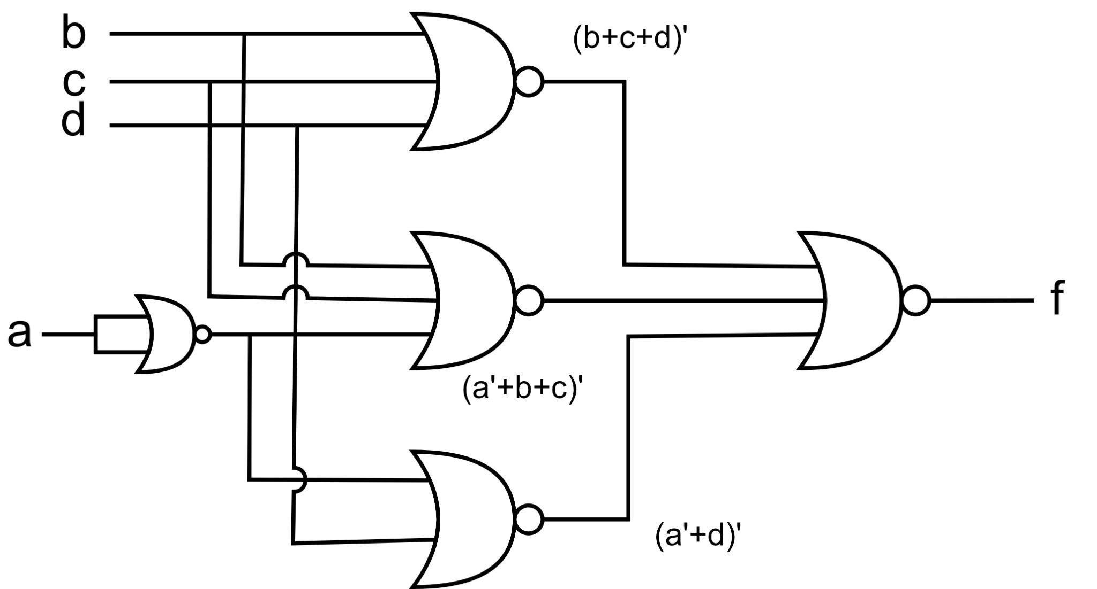

1. **BCD-to-excess-3-code converter:**
   * **Solution:**

The block level implementation will look like the following. Here’s we will be adding 3 (0011) to each bit of the BCD code to create an excess-3 code at output using a 4-bit adder circuit.

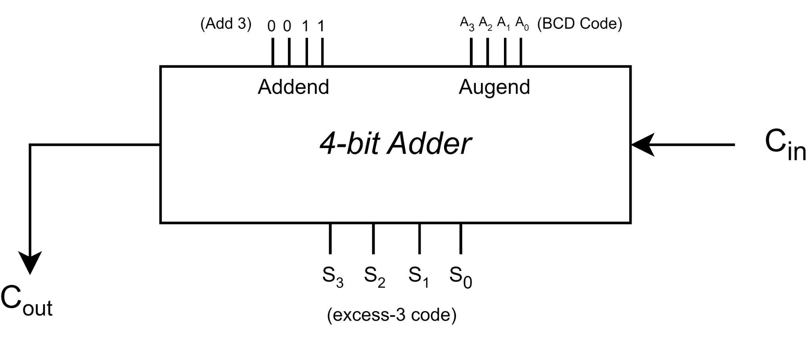

The 4-bit Adder is further broken down into 4 full-adder circuits. This is illustrated in the following:

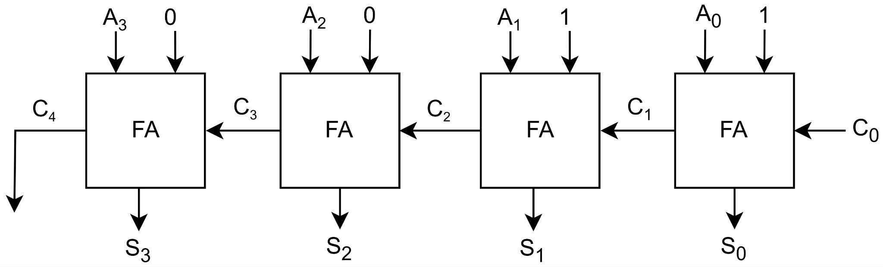

**C0** in this case will be 0, since we are performing addition. In order to convert this circuit into excess-3-code-to-BCD converter, we will need to set **C0** to 1 and alter our logic using xor gates to perform subtraction (Excess-3 code) - 3 = (BCD code). The circuit will look like this:

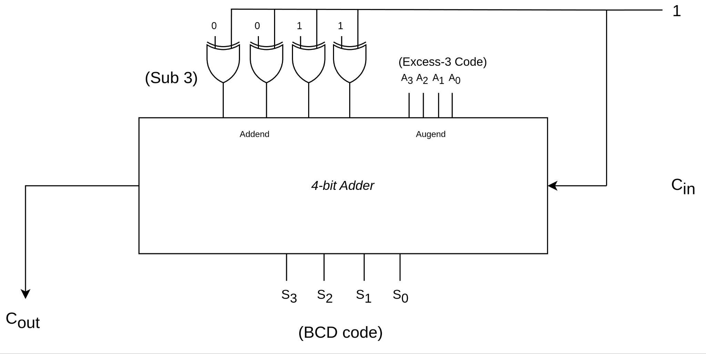

1. **4-bit Input Parity Generator:**
   * **Diagram:**

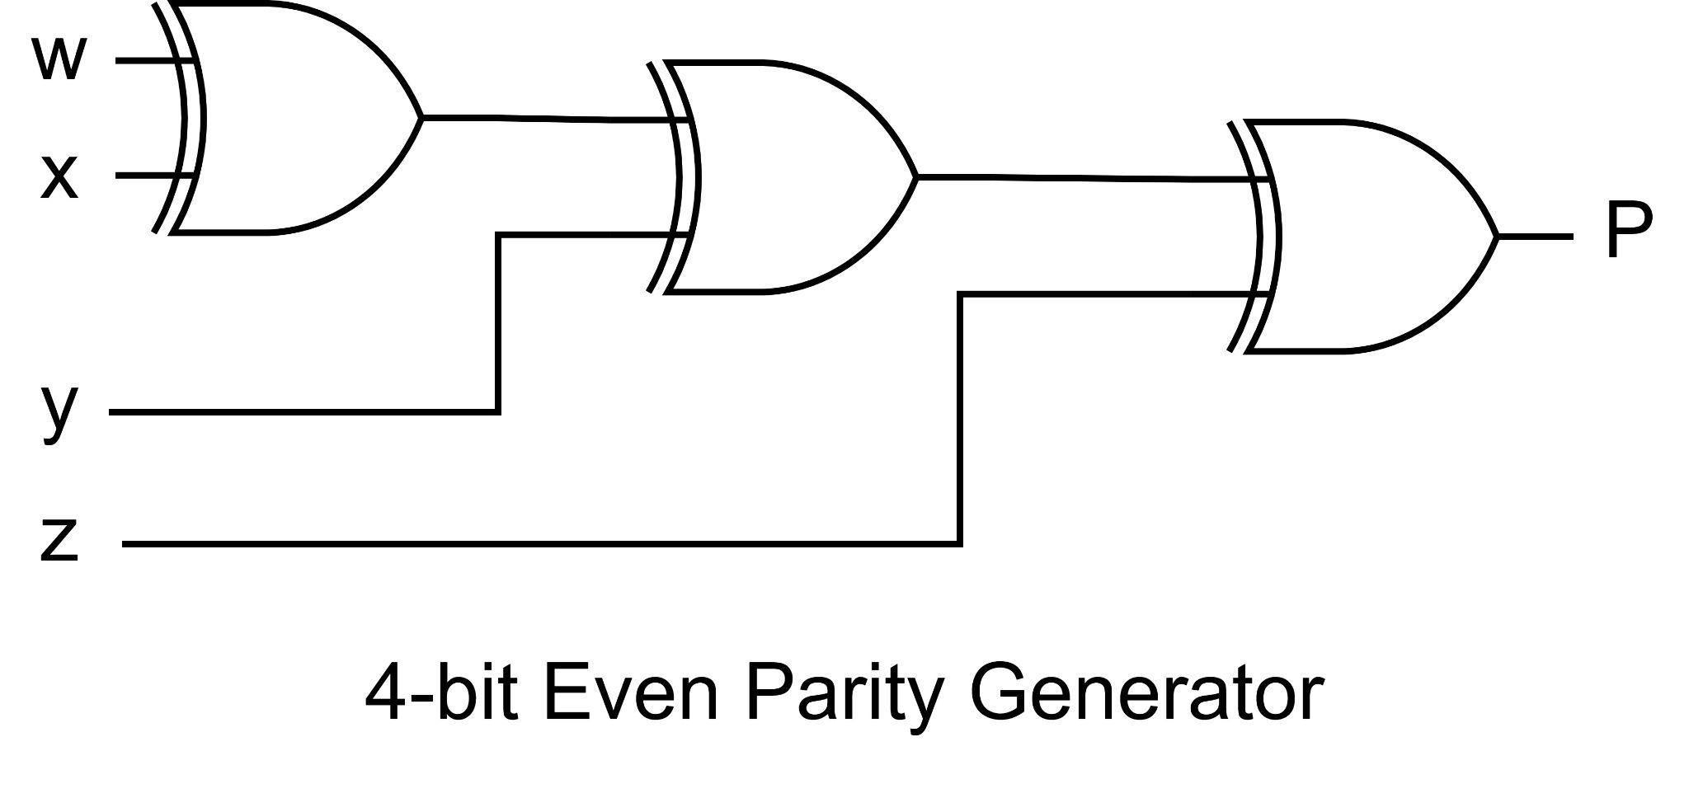

* + **Verilog Code:**

module parity_generator ( input [3:0] data, output reg parity);

always @*

begin

assign parity = data[0] ^ data[1] ^ data[2] ^ data[3];

end

endmodule

* + **Testbench:**

`timescale 1ns/1ps

module test_tb;

reg [3:0] data;

wire parity;

parity_generator dut(.data(data), .parity(parity));

// Stimulus

initial begin

// Test with different inputs

data = 4'b0000; // Even number of high bits

#20;

data = 4'b0001; // Odd number of high bits

#20;

data = 4'b1100; // Even number of high bits

#20;

data = 4'b1011; // Odd number of high bits

#20;

data = 4'b0000; // Even number of high bits

#20;

data = 4'b1101; // Odd number of high bits

#20;

end

endmodule

* + **Output:**

